**SMART LOGIN**

**Project Report**

Submitted towards the course of

**15Z610 EMBEDDED SYSTEMS LABORATORY**

By

Hareeshwar K (17z317)

Karthikeyan S (17z324)

Tejas H Badani (17z354)



**Department of Computer Science and Engineering,**

**PSG College of Technology,**

**Coimbatore.**

**February 2020**

**INTRODUCTION:**

RFID Scanner/Reader scans RFID configured items like cards and tags and is extensively useful when connected to intelligent processing systems like Arduino and Raspberry Pi. RFID is one of the oldest wireless technologies. RFID chips are used to store information digitally, which can then be shared between objects through electromagnetic fields and radio waves.

The heart of this project is Arduino Leonardo with ATmega32U4 chip. The reason is, the Arduino Leonardo has built-in USB Connection that allows the Leonardo to appear to a connected computer as a mouse or a keyboard and thereby be treated as a peripheral device.

Keyboard(keyboard.h) core library is used to make the Arduino send the keystrokes to a connected computer. The code stores the UID of the RFID card and Windows password. When the right card is shown to the RFID reader, the Arduino will send keystrokes for locking the windows and password for unlocking the windows. When the system is already in lock state, the command will unlock the system or else the system is already in unlock state, the command will lock the system. The Arduino IDE running on the PC/Laptop will compile and insert the code into the Leonardo which starts executing the instructions accordingly when the right tag is scanned.

**PROBLEM STATEMENT:**

People often feel tired of typing in the password to unlock PC/laptop every time it gets locked. Sometimes we may forget our Windows password or there is a possibility that it might be cracked. In the growing technology, time and security are to be concerned; Modern technologies require Modern innovations. People like Programmers, Game developers, Data analysts, etc, find it a time consuming job to logout and login a PC during work while taking a break. When the need for something becomes essential, we are forced to find ways of getting it. A smarter unlocking system is needed which would greatly help in reducing the time consumed in logging-in the PC. The user just need to scan their RFID tag to login their PC with this system. This can be used in schools, colleges, universities, offices where the user can lock/unlock their PC/Laptop just by scanning their ID Card.[1]

The requirement is to design a system for locking/unlocking PC without entering the username and password manually every time the user wants to login by using an RFID tag and Arduino Leonardo. With this system in place no more hassles of unlocking our Laptop/PC manually every-time we lock it down.

**COMPONENTS REQUIRED:**

* Arduino Leonardo
* RFID Cards
* RFID Tag
* 10k ohm Resistor
* Thermocol
* Jumper wires
* LED
* RFID Sensor Module-RC 522
* A Windows PC

**SCHEMATIC DIAGRAM:**

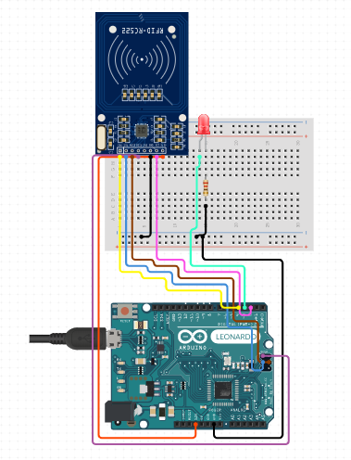

|  |
| --- |
| **CODE**:  #include <SPI.h> // header file  #include <MFRC522.h> // header file for the rfid sensor (mfrc522) library  #include <Keyboard.h> // include the Keyboard header file for the peripheral functionality of a keyboard    // declaration of constant values  #define RETURN_KEY 0xB0 // hex code of the enter key  #define RST_PIN 5 // reset pin  #define SS_PIN 10 // slave select pin  int ledPin = 12; // Pin for the Red LED    MFRC522 rfidSensor(SS_PIN,RST_PIN) ; // defining the sensor variable    char enter = RETURN_KEY; // hex code set for the character    String id;  String acceptedCardID="2395862"; // accepted rfid card's id  int unlocked = 0; // variable to specify locked or unlocked state    void setup( )  {  // initialising the Serial monitor  Serial.begin(9600);  // initialising the keyboard setup  Keyboard.begin();  // initialising the SPI  SPI.begin();  // initialising the RFID sensor  rfidSensor.PCD_Init();  }  // function to convert and store  void convertToString(byte *uid, byte uidSize) the UID in String format  {  id = "";  for (byte i = 0;i<uidSize; i++)  {  // converting to hex equivalent of each character and convert to string  id = id + String(uid[i], HEX);  }  }    void loop( )  {  // checking if a new card is present  if(! rfidSensor.PICC_IsNewCardPresent())  {  return;  }    // reading the card's serial number  if(! rfidSensor.PICC_ReadCardSerial())  {  return;  }    // Printing the new card presence status  Serial.println(rfidSensor.PICC_IsNewCardPresent());  // Printing UID of RFID card to Serial Monitor  //rfidSensor.PICC_DumpToSerial(&(rfidSensor.uid));  // Converting the UID to string format  convertToString(rfidSensor.uid.uidByte,rfidSensor.uid.size);    Serial.println(id);    // checking if the card is accepted  if(id==acceptedCardID)  {  Serial.println("RFID Accepted !!");  // Unlocking when Locked  if(unlocked == 0){  // Enter followed by Password  Keyboard.press(enter);  Keyboard.release(enter);  delay(100);  Keyboard.print("FUTURE");  Keyboard.releaseAll();  delay(100);  Keyboard.press(enter);  Keyboard.releaseAll();  Serial.println("Unlocked !!");  delay(4000);  unlocked = 1;  }  // Locking when unlocked  else if(unlocked == 1){  // CTRL-ALT-DEL  Keyboard.press(KEY_LEFT_CTRL);  Keyboard.press(KEY_LEFT_ALT);  Keyboard.press(KEY_DELETE);  delay(100);  Keyboard.releaseAll();  // DOWN ARROW AND ENTER  Keyboard.press(KEY_LEFT_GUI);  delay(10);  Keyboard.press(‘l’);  delay(100);  Keyboard.releaseAll();  Serial.println("Locked !!");  delay(5000);  unlocked = 0;  }  }  // case of RFID card getting rejected  else  {  Serial.println(" RFID Not Accepted !! ");  // Glow Red LED for 1 second1 as indication  digitalWrite(ledPin,HIGH);  delay(1000);  digitalWrite(ledPin,LOW);  return;  }  } |
|  |

**CHALLENGES FACED:**

* ATmega32U4 chip:

The keyboard.h header file is compiled only for the cases of those Arduino boards that run on the AtMega32U4 processor chip. Hence, development boards like Arduino Uno, Mega 2560, Pro Mini or Arduino Nano cannot be for this application. Only the Arduino Micro, Pro Micro and the Leonardo support this functionality.

* RFID scanner connections:

Absence of connection headers in the RC522 module makes it quite difficult to make the connections with jumpers without soldering connection headers onto the RC522 module. This lead to loose connections causing the scanning system to fail even in the presence of small physical disturbances.

* Delay:

A delay has to specified for each action of locking or unlocking carried out on scanning the RFID tag since a lack of a delay causes the system to unlock and then again go back to lock state all during the short fractions of a second while the card is placed on the scanner.

* Radio Frequency Interference:

Interference from other radio-frequency emitting devices such as wifi access points and objects containing metal (that can reflect RF energy) or water (absorbs RF energy) can strongly affect the condition of the RFID tags and the performance of the RFID scanner.

**CONTRIBUTION:**

Hareeshwar K – Design of circuit and configuration of selected RFID cards for unlocking

Tejas H Badani – Coding of Locking and Unlocking states and commands

Karthikeyan S – Literature Survey, Initial tryouts with Arduino Uno, Documentation

**REFERENCES:**

|  |  |
| --- | --- |
|  | 1. <https://create.arduino.cc/projecthub/kksjunior/windows-pc-lock-unlock-using-rfid-5021a6> 2. <https://www.circuito.io/app?components=9442,11286,761981> 3. <https://www.arduino.cc/reference/en/language/functions/usb/keyboard/> 4. <https://www.arduino.cc/en/Reference/KeyboardModifiers> 5. https://www.arduino.cc/en/Tutorial/KeyboardLogout |

**REPOSITORY:**

<https://github.com/HareeshwarKarthikeyan/Unlocking-PC-with-RFID-and-Arduino>

**SNAPSHOTS :**

**CODE AND OUTPUT :**

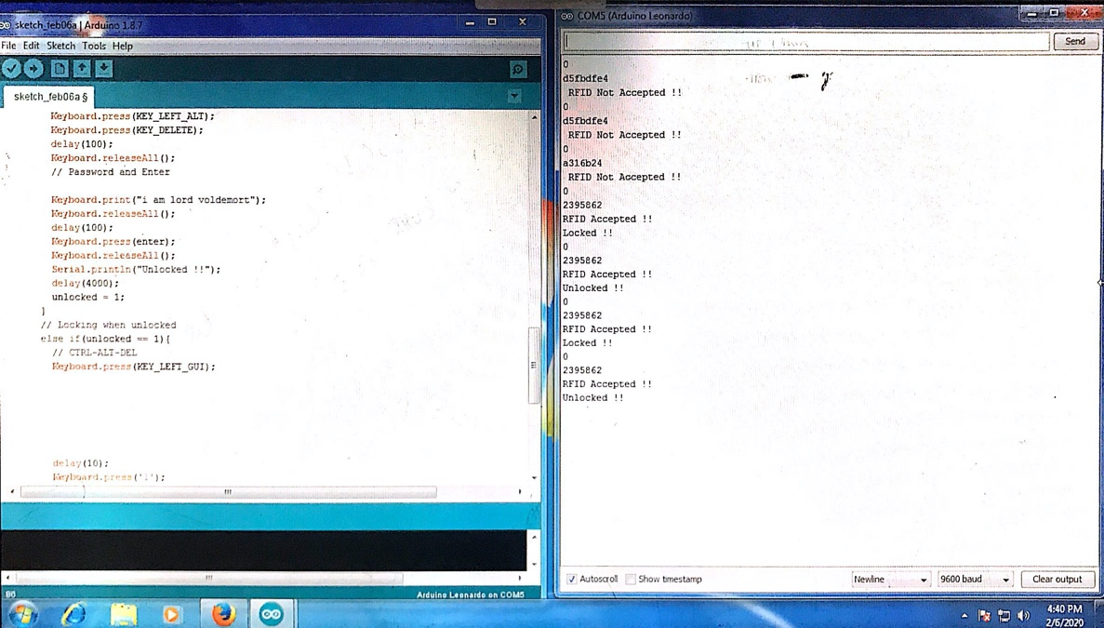

**WORKING SETUP :**

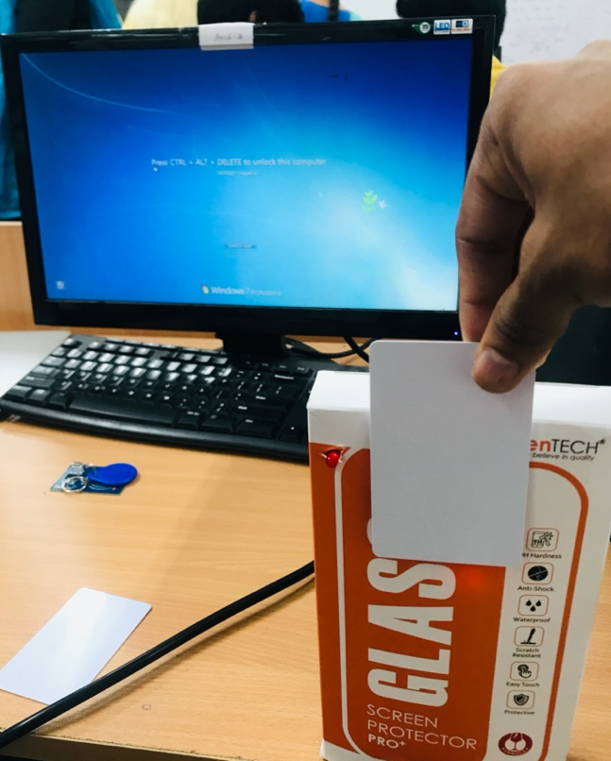 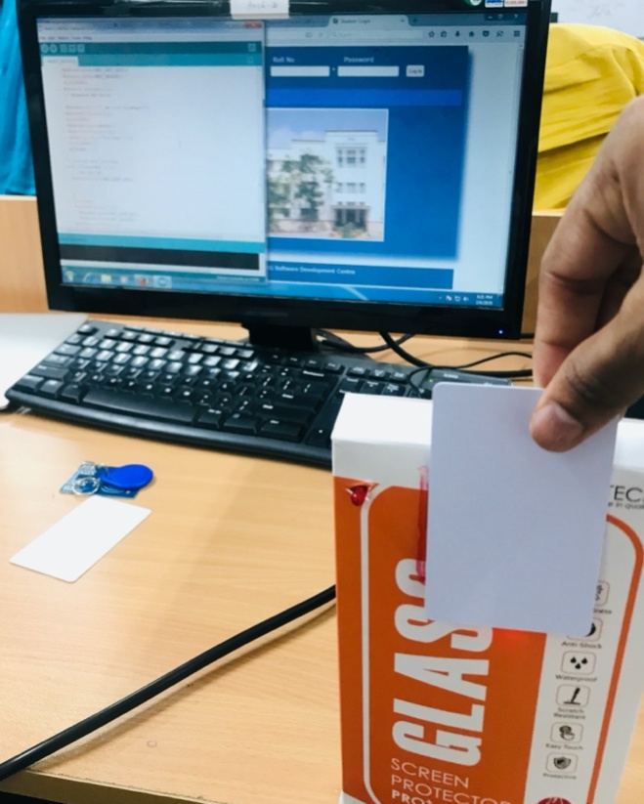

Unauthorised Card - Doesn't unlock PC and glow sRed LED Authorised Card – Unlocks PC successfully